Update Database
(*Please Complete All Questions*)

Patient’s Name: Today’s Date: ____ / _____ / _____
Pain and Symptom History

Mark on the line below the point that best represents the severity of your pain ‘Most of the time’.
Please Draw Your Pattern of Pain

On the Diagram Below
Unbearable Pain
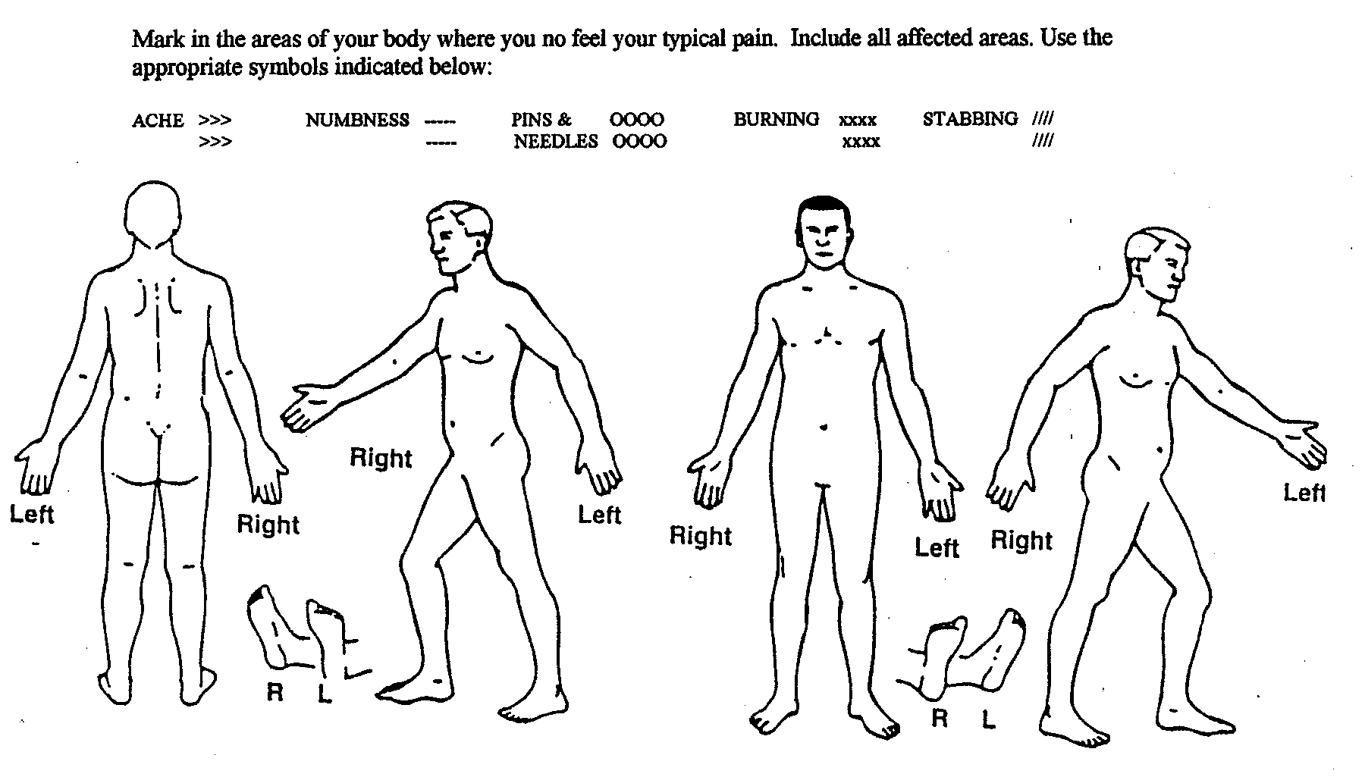
______
Mark in the areas of your body where you now feel your typical symptoms. Include all affected areas. Use the appropriate symbols below to describe your symptoms.

______
No Pain

On a scale of 0 to 10 (where 1 is very mild pain and 10 is the worst pain)
Please Rate Your Pain - (Use a Single Number (2, 5, 9) OR A Range of Numbers (3-4, 8-10, 1-3)
(For Example: 2/10, 8/10, 3-5/10, 7-9/10)
(*Please Check One Below – This is IMPORTANT!)
Would You Characterize Your Pain As Being?
Mild
Moderate
Severe
______ / 10_ Pain At its Best (0 – 10)
_ _____/ 10_ Pain At its Worst (0 - 10)
___ ___/ 10_ Pain On Average (0 - 10)
AND - Please Check the One that best describes your pain pattern:
I Am Experiencing: MORE GOOD DAYS (Than Bad Days)
I Am Experiencing: MORE BAD DAYS (Than Good Days)
I Am Experiencing: EQUAL GOOD & BAD DAYS

Does Coughing or Sneezing ‘Increase’ your ‘Pain’? YES NO

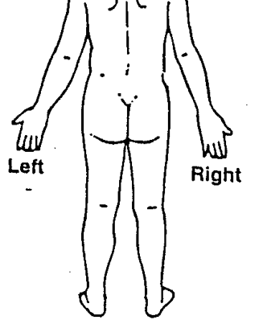 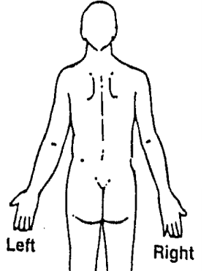
Back Pain Neck Pain
‘Circle’
Leg Pain Arm Pain
All That Apply
Both Both

If you have BOTH - Back + Leg Pain (and/or) Neck + Arm Pain

What % Percentage (of 100%) is: BACK v. LEG OR NECK v. ARM
(e.g. 30% Back Pain & 70% Leg & Buttock Pain – with the “Total Adding up to 100%”
(e.g. 60% Neck Pain & 40% Arm & Shoulder Pain – with the “Total Adding up to 100%”
Circle – Is your pain on the R or L or Both

_______ % BACK Pain vs. _______ % LEG → Right or Left or Both

_______ % NECK Pain vs. _______ % ARM → Right or Left or Both

